

**Cambridge Hospital**

|  |  |  |
| --- | --- | --- |
| **Supervisor:** | *LÊ THANH NHÂN* | |
| **Semester:** | *1* | |
| **Batch No:** | *T12008E1* | |
| **Group No:** | *5* | |
| **Order:** | **Full name** | **Roll No.** |
| *1.* | *PHAN TRUONG LINH* | *Student1275074* |
| *2.* | *DAO MINH TRIET* | *Student1275237* |
| *3.* | *MAI CONG THANH* | *Student1275371* |

***Month****: 11* ***Year :*** *2020*



This is to certify that

|  |  |
| --- | --- |
| **Mr.** | **PHAN TUONG LINH** |
| **Mr.** | **DAO MINH TRIET** |
| **Mr.** | **MAI CONG THANH** |

Have successfully Designed & Developed

|  |  |  |
| --- | --- | --- |
|  |  |  |
| **CAMBRIDGE HOSPITAL** | | |

Submitted by:

|  |
| --- |
| **Mr. LE THANH NHAN** |

Date of Issue:

|  |  |
| --- | --- |
|  |  |

Authorized Signature:

|  |  |
| --- | --- |
|  |  |

**Project Acknowledge**

* eProject is a practical exercise, helping us to synthesize knowledge into a unified block. Create a specific product in the learning process.
* Come up with a roadmap and use the tools to get it done

**Project Objectives**

The Objective of this program is to give a sample project to work on real life projects. These applications help you build a larger more robust application.

The objective is not to teach you JavaScript/Dreamweaver but to provide you with a real life scenario and help you create basic applications using the tools.

You can revise the chapters before you start with the project.

This project is meant for students who have completed the module of ***HTML5***. These programs should be done in the Lab sessions with assistance of the faculty if required.

It is very essential that a student has a clear understanding of the subject. Students should go through the project and solve the assignments as per requirements given.

Kindly get back @ [eprojects@aptech.ac.in](mailto:eprojects@aptech.ac.in) in case of any doubts regarding the application or its objectives

**Synposis**

Cambridge Hospital is one of the famous hospital in the town since 1928, now the hospital organization wish to change their existing website completely. The website which they demand is suppose to provide user friendly environment and navigation. The important menu must be stated in the top section of the webpage. Also a decent look out and color combination is expected.

The website is to be developed for the Windows Platform using HTML5, JavaScript and Geolocation. The site should work well in all leading browsers including Chrome, IE, Firefox etc.

**Problem Definition**

Compared to the old days, medicine is now much more developed in terms of both knowledge and matter. More and more hospitals were built. Therefore, if a hospital wants to develop, it is necessary to have support tools in the media.

In the current technology era, the renewal of the hospital website is something very necessary. Create a lot of friendliness and trust for your patients.

On this website, hospital clients can express their suggestions to make the hospital better and better.

**Identify problem**

* Provide information includes some description about the Cambridge Hospital like who is the founder and some of the achievements of handling critical cases..
* Menu includes important contents such as:
* “About us”, “Department”, “Facility”, “Services”, “Centres”, “Academic”, “Contact Us”, “Vacancies”, “Query”, Feedback”, “Success Stories”.
* Each section must provide brief information
* Also each link must be properly hyperlinked, images must be used wherever necessary
* Contact Us page must flash the address of all the location where the hospital is located. Address of the hospital should be displayed using GeoLocation API
* Department details like *“helpdesk”, “registration”, “Doctor Schedule”, Billing and Accounts”* and so on must be included
* Facility like *“rooms”, ICU”, Medical Facility”, “Other Facility”*
* Services like *“general services”, “Health Check-up”, “Specialties”* and so on
* Centres like *“diagnostic centre”, “cancer centre”, “heart centre”, “community health centre*
* Feedback must be taken and Query must be allowed to enter
* The website supposed to provide user friendly environment and navigation.

**User**

- Access and refer to the information placed on the website.

- Contribute ideas and feedback to the hospital

- Find out some information about the hospital

**Admin**

- The website must provide all necessary information in a clear and detailed manner and provide user friendly environment and navigation

- Change themes, images suitable for each period of time

- Good interaction with users

**User**

**Input**

- Contribute to the hospital

- search information

**Process**

**-**Log in to check / update personal information in

your registered account

-Check the information provided for the hospital

-Receive comments from users

- Check information

**Output**

- Notice of successful information change

- Notification of successful suggestions

- successful information search

**Admin**

**Input**

-Login information of Admin

- Information Change / Add / Delete / Edit

- Get feedback and reviews from user

**Process**

- Add / Edit / Delete system parts

-Reply / delete comments from users

**Output**

**-**Logged in successfully

- Successful information change

- Reply comments successfully / failed

**Hardware/ Software Requirements**

**User**

* A minimum computer system that will help you access all the tools in the courses is a Pentium 166 or better
* 64 Megabytes of RAM or better

**Admin**

* Notepad/HTML editor
* Dreamweaver
* IE 5.0/ Netscape 6.0

**Server**

Log in

**Device**

**Windows Platform**

**HTML**

**CSS**

**Javascript**

**Jquery**

**Bootstrap**

**AngularJS**

**Client**

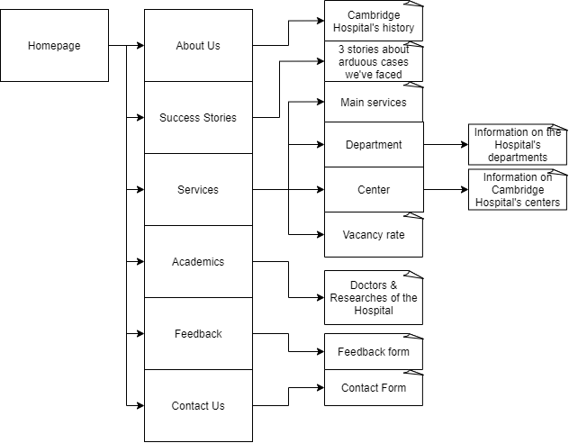

**Screenshots:**

1. **Homepage**

* Default Page
* Toggle links to “about us”, “success stories”, “academics”, “services”, “contact us”, “feedback”.
* Carousel display images of Cambridge Hospital
* Search bar allows query

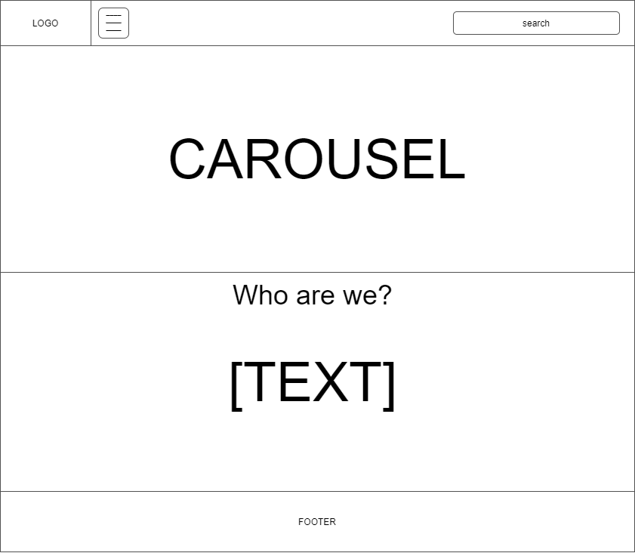

1. **About us**

* Led from navigation bar’s toggle button
* Display general information of Cambridge Hospital

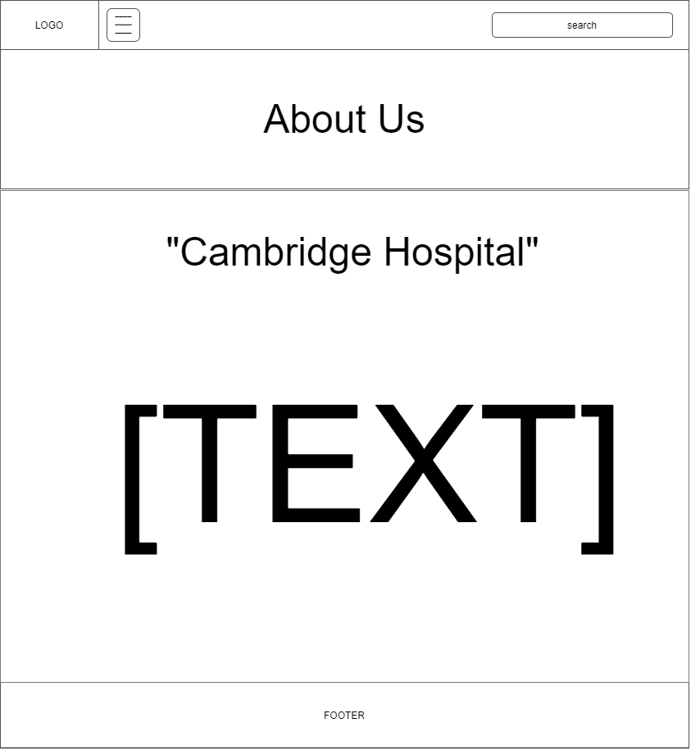

1. **Success Stories**

* Led from navigation bar’s toggle button
* Display success stories of our arduous cases

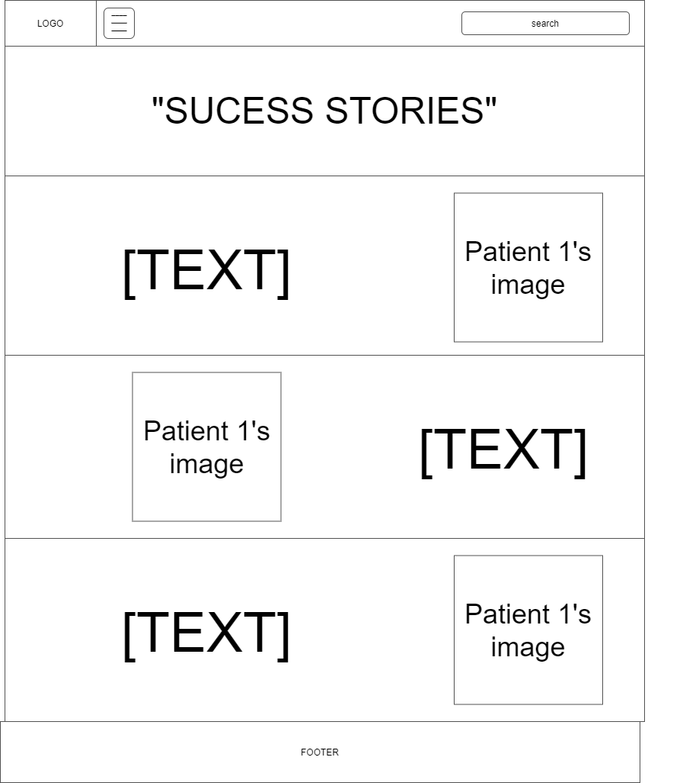

“Success Stories”

1. **Academics**

* Led from navigation bar’s toggle button
* Display general info about Cambridge Hospital’s Academics achievements



“Academics”

Doctor

1’s image

Doctor

2’s image

Doctor

3’s image

1. **Services**

* Led from navigation bar’s toggle button
* Display general info about Cambridge Hospital’s services
* Links to “Departments”, “Centers”, “Vacancies”

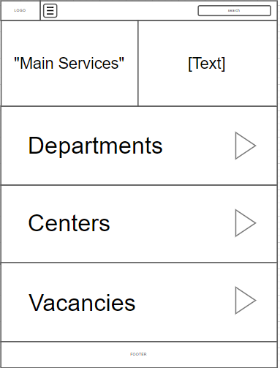

1. **Homepage/Service/Departments**

* Led from “Services”
* Display Links to all of the Hospital’s departments
* Links to multiple pages of specific departments (“unrequired to code”)

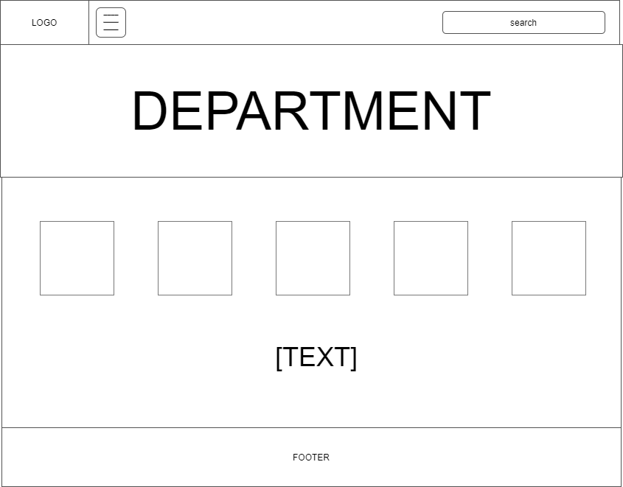

**Homepage/Services/Department/SpecificDepartment**

* Led from Departments
* Display information of one specific departments among tens of departments displayed in “department”

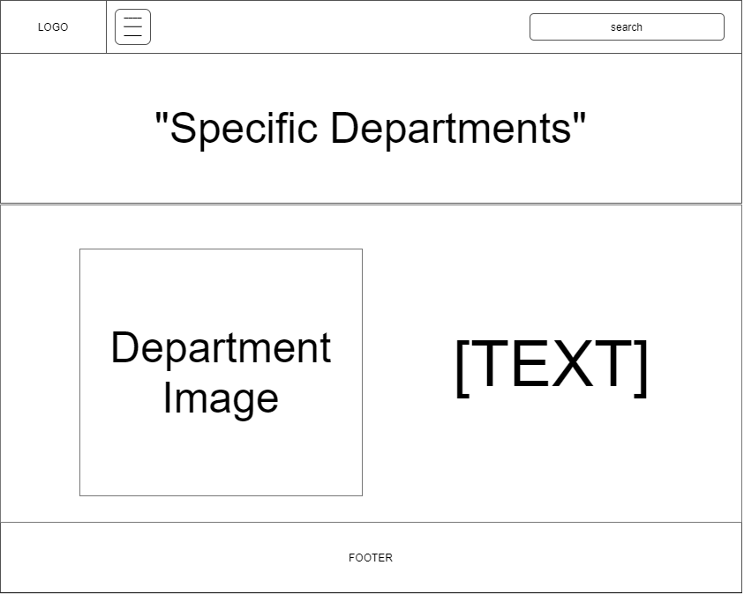

1. **Contact Us**

* Led from navigation bar’s toggle button
* Display general contact information of Cambridge Hospital and Sales Office; display contact form; display geolocation

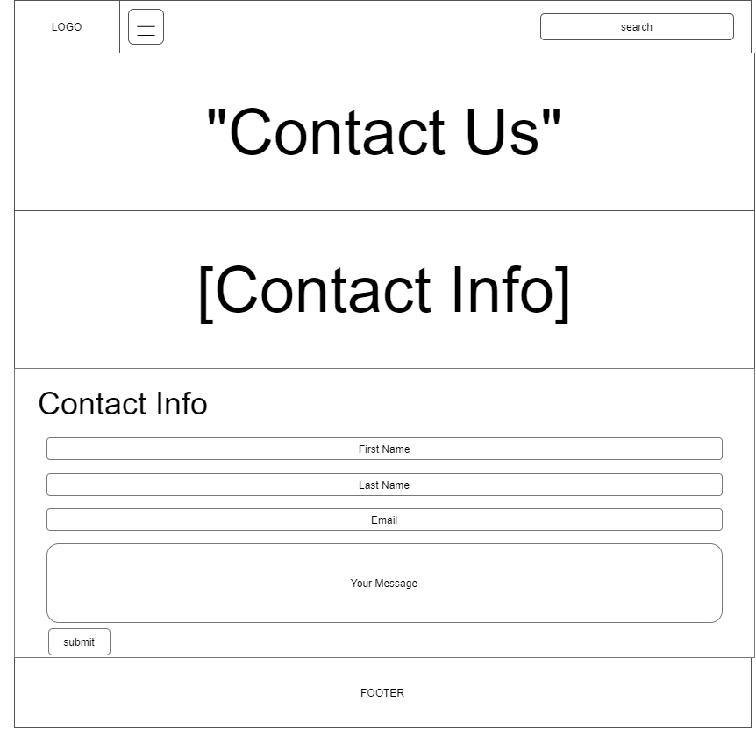

1. **Feedback**

* Led from navigation bar’s toggle button
* Display feedback form

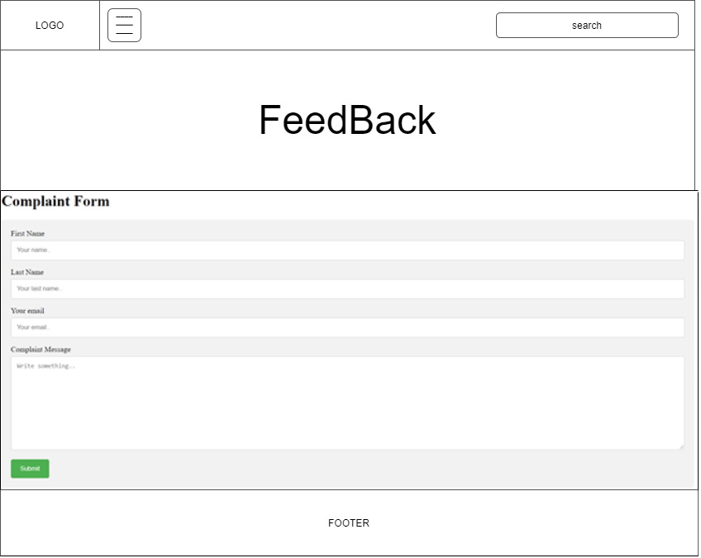

|  |  |  |  |
| --- | --- | --- | --- |
| **S.No.** | **Features Tested** | **Remarks** | |
| **Yes** | **No** |
| **1.** | Email cannot be left blank and must be in the correct format | **✓** |  |
| **2.** | First and last name must not be blank | **✓** |  |

|  |  |  |  |
| --- | --- | --- | --- |
| **S.No.** | **Aspect tested** | **Suggestions/**  **Remarks** | |
| **Yes** | **No** |
| **1.** | Have all the modules been properly integrated and are they completely functional ? | **✓** |  |
| **2.** | Does each unit meet its objective and purpose ?  Are all the validations happening as specified in Process Design? | **✓** |  |
| **3.** | Have all Design and Coding standards been followed and implemented ? | **✓** |  |
| **4.** | Is the GUI design consistent all over? | **✓** |  |
| **5.** | Are the codes working as per the specification ? | **✓** |  |
| **6.** | Does the application’s functionality resolve the client problem, and satisfy his needs completely ? | **✓** |  |
| **7.** | Have the hardware and software been correctly chosen ? | **✓** |  |
| **8.** | Additional features and utilities that give value addition to the entire project. | **✓** |  |

|  |  |  |  |  |  |  |  |
| --- | --- | --- | --- | --- | --- | --- | --- |
| **No** | **Member** | **Contents** | **Page Name** | **Activity Plan** | **Date of Preparation of Activity Plan** | | |
| **Planed Start Date** | **Actual Start Date** | **Actual Days** | **Status** |
| 1 | PHAN TUONG LINH | contact us by hotline, email, or on social network,... | contact us.html | 7-Nov-20 | 7-Nov-20 |  |  |
| 2 | Founder, ideology, story,.. | About us.html | 7-Nov-20 | 7-Nov-20 |  |  |
| 3 | Our arduous cases that we've been through | success story.html | 7-Nov-20 | 7-Nov-20 |  |  |
| 4 | How we are the pioneers in medical researches | academics.html | 7-Nov-20 | 7-Nov-20 |  |  |
|  | | | | | | | |
| 1 | DAO MNIH TRIET | occupation of hospital beds at the moment | Vacancy.html | 7-Nov-20 | 7-Nov-20 |  |  |
| 2 | Register forms, appointment booking registration | query.html | 7-Nov-20 | 7-Nov-20 |  |  |
| 4 | Cambridge Hospital's equiments and technology(i.e: ventilators,...) | facility.html | 7-Nov-20 | 7-Nov-20 |  |  |
|  | | | | | | | |
| 1 | MAI CONG THANH | health care, customer care, information services, transportation,... | services.html | 7-Nov-20 | 7-Nov-20 |  |  |
| 2 | to serve by lots of professional doctors have wide experience | departments.html | 7-Nov-20 | 7-Nov-20 |  |  |
| 3 | Feedback form | feedback.html | 7-Nov-20 | 7-Nov-20 |  |  |
| 4 |  |  |  |  |  |  |

**Content**

**Page 1**: Problem Definition

**Page 2**: Problem Definition

**Page 3**: Customer Requirements Specifications

**Page 4**: Customer Requirements Specifications

**Page 5**: Customer Requirements Specifications

**Page 6**: Architecture and design of the project

**Page 7**: Site Map

**Page 8**: Screenshots - Homepage

**Page 9**: Screenshots - About Us

**Page 10**: Screenshots - Success Stories

**Page 11**: Screenshots - Academics

**Page 12**: Screenshots - Services

**Page 13**: Screenshots - Departments

**Page 14**: Screenshots - Specific Departments

**Page 15**: Screenshots - Contact Us

**Page 16**: Screenshots - Feedback

**Page 17**: Testing Document

**Page 18**: Final Checklist

**Page 19**: Task Sheet